Title of Report: Exploiting Parallelism for FPGA Designs

Name of Candidate: David Robert Clarke

Degree Program: B.Eng Electrical & Electronic Engineering

Project Supervisor: Dr D.J.Holding

Name of Institution: Electrical & Electronic Engineering,
School of Engineering and Applied Science,
Aston University.

Date of Submission: 06/2001
AIM OF PROJECT:

To investigate, design and build a FPGA based matrix multiplier, which would be used in alternative serial and parallel matrix multiplication. The system researched will be used to monitor the processing speed difference between the two entities. In the latter stages, partitioning techniques involved in parallel matrix multiplication operations will also be studied.

OBJECTIVES:

- To Investigate and develop a VHDL scripted algorithm which implements the matrix multiplier

2) To investigate various architecture devices

3) To Interface the FPGA-based design to a computer monitor

4) To stimulate the FPGA design with test signals using a test bench environment

SCHEDULE OF WORK:

- Software

  - To develop a VHDL based design of the matrix multiplier entity and architecture.

1.2 Study what/how different partitioning techniques on data and investigate how they can be used to get the most productive parallel multiplicative result.

- Research

2.1 Study into which architectures will give the most effective multiplicative results.

3) Interface

3.1 To investigate how the separate matrices can be inputted from the user and sent to the FPGA-based design.

3.2 To investigate how the timing data and matrix multiplication results from the FPGA-based design can be outputted and displayed.

4) Test bench

4.1 To verify that the FPGA-based design behaves accurately.

  - Carry out studies to test the full extent the FPGA-based design's processing power.

BODY OF THE REPORT
Given the title of the project “Exploiting parallelism for FPGA designs,” a number of ideas initially came to mind. Reading further into the project description “to implement computationally intensive algorithms (such matrix multiplication) using essentially sequential data processing techniques.” It became clear from the start, the project would involve developing a system based around the mathematical operation of matrix multiplication. How could parallelism be exploited in a matrix multiplication system? Answer, using parallel processing. Research would need to be undertaken in the issues surrounding matrix computations performed in a parallel system architecture. What test could be undertaken to exploit parallelism? Comparison of a serial DSP architecture against a developed parallel architecture. The key tests would be evaluating processing power (number of clock cycles) required to perform matrix multiplication using either serial or parallel architecture. With the aim of the project loosely in place, the initial design could now be developed.

(i)Serial
Matrix
Multiplicative
Operation

(ii)Parallel
Matrix
Multiplicative
Operation
Matrices
Input
Output Answer
Output Operation time

Figure 1: Initial High Level Flow Diagram

Putting the aim of the project into context a high level view of the design can be drawn up (shown in Figure 1). The design flow shows that given two matrices, by choosing either to process the data in a serial or a parallel fashion, a matrix product will be achieved along with the number of clock cycles required to process the data. Keeping in mind the high level flow diagram, the input, output and processes can be researched in turn.
The mathematics involved in matrix multiplication are simple, but tedious when considering higher order matrices. The Croft Davison Hargreaves “Engineering Mathematics” book explained clearly what was involved in such a matrix multiplication. This information has been extracted and inserted into Part 1 of the appendix. The single most important fact, for matrix multiplication to take place the number of columns of matrix A must be the same as the number of rows of Matrix B. This theory was taken on board; after the initial flow diagram, a second was drawn up which goes into the separate processes in more detail.

Figure 2 : Second High Level Flow Diagram

From the start, this digital design would be implemented using the hardware description language, VHDL. Knowledge gained from the 2nd Year VHDL course helped initially in the designs inception, however much was to be learnt about VHDL from this project.
The flow diagram of Figure 2 could now be realised initially in block diagram form.

Figure 3: Very basic system which could implement the matrix multiplication algorithm.

Initial thoughts were, input matrices A and B’s data in a serial fashion. The first digital system to be met would be the size comparator. Matrix A’s data would be input first, the number of columns would be calculated and stored. Matrix B’s data would then be input, the number of rows would be calculated, stored and then compared against the value of Matrix A’s column size. If the two magnitudes did not match then the data flow would be halted and an error signal would be outputted. The finite state machine is surrounded in a dashed border to illustrate that it isn’t detailed but is involved in the next stage of the data flow process.

- I have purposefully missed out a large chunk of further evolutions because they were dead end ideas, will include these however after I’ve put in the essential ideas governing the project.

A proverbial dead end had been reached in the initial phase of this design. The design was becoming too large, too complicated, too fast. To ensure the behaviour of the system could be worked out from first principles, a simple specification needed to be derived .

- The system would be required to multiply together two matrices. Matrix A and Matrix B both having 2 rows by 2 columns. An example of such matrices needing to be multiplied together are shown below.

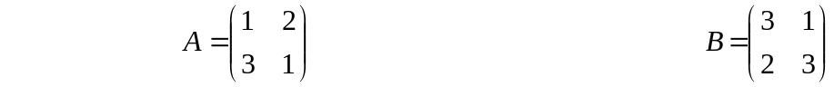
Matrix_A Matrix_B

- The magnitude of each element may not exceed the value 3. Hence each element can be represented by a 2-bits of binary data, .

Lets NOT have a separate Multiplication selection input. Lets have one bus of data inputting into 1 finite state machine.

There are 4 different multiplication partitioning combinations possible at the moment.

The dimensional byte is not required, the dimensions of the matrix are known.

Hence

Data Bus Width required (One Matrix) = element mag + partition combinations

Data Bus Width required (One Matrix) = 4 + 4 = 8 decimal

Remember the two matrices data will share the same partitioning selection.

Data Bus Width required (Two Matrices) = 8 + 4 = 12 decimal = 4 bits

Lets work out the code for each item

Element Magnitude | Partitioning Selection | Matrix A Binary Code Given | Matrix B Binary Code Given
0 | non | 00 | 00
1 | non | 01 | 01
2 | non | 10 | 10
3 | non | 11 | 11
non | 1 | 00 | 01
non | 2 | 00 | 10
non | 3 | 00 | 11
non | 4 | 01 | 00

The data in the last two columns combine to give the transmitted code. This code is then sent on the data bus. The top four rows give information on the magnitude of the element in each matrix. The bottom four rows give partitioning information, i.e. use 1,2 or 4 multipliers

Lets use an example to show how this binary code will be implemented:-

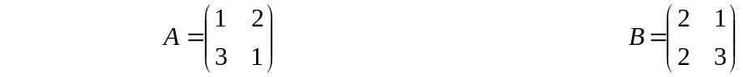

The partitioning selection 4-bit code can be represented by #
There can only be 4 combinations of this code, one for each separate partitioning value.

I had reached a stage where the design model was becoming a hybrid of the FSM controller and the DSP, the logic that was being created was an amalgamation of the two. The two entities (finite state machine, digital signal processor) needed to be defined and created separately. A rethink was required, the system needed to be redesigned. To achieve the aim of the project the top down design methodology needed to kept simple. To keep ideas simple emphasis was placed on the use of behavioural VHDL, this would keep the level of abstraction at a high enough level in order to create the individual entities. What the individual entities did, could be described and created. The manner of how the lower level components of the entity are structurally connected was of no concern. With this in mind the next step in the design process could now be undertaken.
With reference to the aim of the project, the extract “partitioning techniques involved in parallel matrix multiplication” was a major issue when designing the system. To exploit parallelism and partitioning of data in a parallel architecture, the thought of using three different matrix multiplier set ups sprung to mind. Individual systems consisting of 2, 4 and 8 multipliers would be implemented. Indeed more configurations could be implemented i.e. >4, or even two, however, three systems would show results consisting of low, medium and high levels of processing.
Going back to basics, the system should consist of

FSM Controller - FSM which enables logic functions to operate

DSP - the DSP alters the signal, i.e. processes the signal so it is in a different form

Inputs - Two matrices, Matrix A has 2 columns by 2 rows, Matrix B also has 2 columns by 2 rows. The magnitude of each element is known as shown below.

This data would be serially input into three different ASM controllers. Each ASM controller would operate in one of three ways:-

- Configuration one would comprise of an individual ASM Controller and DSP, the DSP would consists of two multipliers.

- Configuration two would comprise of an individual ASM Controller and DSP, the DSP would consist of four multipliers.

- Configuration three would comprise of an individual ASM Controller and DSP, the DSP would consist of eight multipliers.

Shown below is a very high level view of how the three processors would look:
ASM Controller
Matrix Input
Matrix Multiplication
Answer calculated in time T1
Matrix Multiplication
Answer calculated in time T3
DSP (2xMultiplier)
ASM Controller
DSP (4xMultiplier)
ASM Controller
DSP (8xMultiplier)
Matrix Multiplication
Answer calculated in time T2

Figure 4: Highest level Look at the Matrix Multiplier Configurations

Some questions might obviously be raised. Why are three separate configurations being tested?

Answer: If three configurations were culminated into one ASM controller with one DSP, there could be some problems. Firstly the single ASM controller and DSP would have logic (which is redundant for some configurations and active for others) this extra logic could unneedingly slow down the processing of data . Hence the processing time results would be difficult to differentiate for the three different configurations.
Having three processors working on the data at the same time would show in one sitting will show what the difference in the processing speeds are. There would be no need to re-enter the matrix data for a second or third time in order to calculate the Matrix product for a different configuration.

A step by step guide to show how the two multiplier system (configuration 1) operates
(Please refer to Configuration 1 schematic)

- Data is received by the ASM controller. The ASM controller then communicates with the DSP. The DSP is made up of a TWO multipliers with an adder circuit and memory.

- The controller sends the elemental data down a bus (which is eight bits wide), this bus is used to accommodate data for the four matrix elements.

- Each multiplier has two inputs (1 for Matrix A data, another for Matrix B data), each input is two bits wide because every matrix element is in the decimal range 0 to 3 (for this study). 0 to 3 in decimal represents 00 – 11 in binary, hence the reason why the input to the multiplier is required to be 2-bits wide.

- The initial two 2-bit data elements are multiplied together (A(0)B(0)), the result is sent to a 4-bit bus at the multipliers output. This product is added to the two 4-bit elemental product A(1)B(2) which is produced by the second multiplier. After this addition takes place, this sum is stored in memory address 1.

- The next two 2-bit data elements are multiplied together (A(0)B(1)), the result is sent to a 4-bit bus at the multipliers output. This product is added to the two 4-bit elemental product A(1)B(3) which is produced by the second multiplier. After this addition takes place, this sum is stored in memory address 2.

- The next two 2-bit data elements are multiplied together (A(2)B(0)), the result is sent to a 4-bit bus at the multipliers output. This product is added to the two 4-bit elemental product A(3)B(2) which is produced by the second multiplier. After this addition takes place, this sum is stored in memory address 3.

- The next two 2-bit data elements are multiplied together (A(2)B(1)), the result is sent to a 4-bit bus at the multipliers output. This product is added to the two 4-bit elemental product A(3)B(3) which is produced by the second multiplier. After this addition takes place, this sum is stored in memory address 4.

- After four cycles of data processing, with all the matrix product data stored in memory, the data is then outputted and displayed.
Matrix A
Data Element
Matrix B
Data Element
Matrix B
Data Element
Matrix A
Data Element
A(2)xB(1) + A(3)xB(3)
A(2)xB(0) + A(3)xB(2)
A(0)xB(1) + A(1)xB(3)
A(0)xB(0) + A(1)xB(2)
TWO 4-BIT DATA BUSES HOLDS MATRIX DATA ELEMENT PRODUCT
8-BIT
Elemental Data Bus
Matrix A and Matrix B data

2-BIT
MULTIPLIER
MULTIPLIES TOGETHER TWO SETS OF MATRICES ELEMENT DATA BITS TO FORM THE MATRIX DATA ELEMENT PRODUCT

4-BIT
ADDER
THE MATRIX DATA ELEMENT PRODUCT WORDS ARE ADDED TOGATHER

MEMORY
STORES FOUR SETS OF SUM-OF PRODUCTS
5-BIT DATA BUS HOLDS SOP AND PRODUCTS
ALLOCATE DATA TO MEMORY LOCATION 1, 2, 3 OR 4

2-BIT
MULTIPLIER
MULTIPLIES TOGETHER TWO SETS OF MATRICES ELEMENT DATA BITS TO FORM THE MATRIX DATA ELEMENT PRODUCT

FSM CONTROLLER
CONFIGURATION_1
D-TYPE CLOCKING SIGNAL 4-BITS, WHEN LOW to HIGH, DATA at D IS STORED

Figure 5 : Configuration 1, parallel processing system containing 2, 2-bit multipliers and a 4-bit adder
A step by step guide to show how the two multiplier system (configuration 2) operates
(Please refer to Configuration 2 schematic)

- This is very similar in design to configuration 1. They differ in a number of ways. A 16-bit Elemental Data Bus is required to hold a larger throughput of elemental matrix data, twice as much as before.

- The EIGHT matrix data elements are input to FOUR 2-bit Multipliers.

- The products are outputted to FOUR 4-bit data buses. These FOUR data buses are input to TWO 4-bit adders.

- The sum of products is sent on TWO 5-bit data buses to memory, one data bus taking up TWO memory elements, while the other 5-bit data bus takes up the remaining TWO.

- After two cycles of data processing, with all the matrix product data stored in memory, the Matrix product is then outputted and displayed.

Matrix A and Matrix B
Data input
Matrix B
Data Element
Matrix B
Data Element
Matrix A
Data Element
Matrix A
Data Element
Matrix B
Data Element
Matrix A
Data Element
Matrix B
Data Element
Matrix A
Data Element
A(2)xB(1) + A(3)xB(3)
A(2)xB(0) + A(3)xB(2)
A(0)xB(1) + A(1)xB(3)
A(0)xB(0) + A(1)xB(2)
FOUR 4-BIT DATA
16-BIT
Elemental Data Bus

2-BIT
MULTIPLIER

4-BIT
ADDER

MEMORY
STORES FOUR SETS OF SUM-OF PRODUCTS
TWO 5-BIT DATA BUSES HOLD SOP AND PRODUCTS

FSM CONTROLLER
CONFIGURATION_2

2-BIT
MULTIPLIER

2-BIT
MULTIPLIER

2-BIT
MULTIPLIER

4-BIT
ADDER

D-TYPE CLOCKING SIGNAL, WHEN LOW to HIGH, DATA at D IS STORED

Figure 6 : Configuration 2, parallel processing system containing 4, 2-bit multipliers and 2, 4-bit adder
A step by step guide to show how the two multiplier system (configuration 3) operates
(Please refer to Configuration 3 schematic)

- This is very similar in design to configuration 1&2. They differ in a number of ways. A 32-bit Elemental Data Bus is required to hold a larger throughput of elemental matrix data, again twice as much as before.

- The SIXTEEN matrix data elements are input to EIGHT 2-bit Multipliers.

- The products are outputted to EIGHT 4-bit data buses. These EIGHT data buses are input to FOUR 4-bit adders.

- The sum of products is sent on FOUR 5-bit data buses to memory, one data bus takes up ONE memory element, hence each memory element has a direct link to their personal sum of products.

- After one cycle of data processing, with all the matrix product data stored in memory, the Matrix product is then outputted and displayed.

D-TYPE CLOCKING SIGNAL 4-BIT,WHEN LOW to HIGH, DATA at D IS STORED
32-BIT
Elemental Data Bus
Matrix A and Matrix B data serially Inputted

ASM CONTROLLER
CONFIGURATION_3
Matrix A
Data Element
Matrix B
Data Element
Matrix B
Data Element
Matrix A
Data Element
Matrix A
Data Element
Matrix B
Data Element
Matrix A
Data Element
Matrix B
Data Element
Matrix A
Data Element
Matrix B
Data Element
Matrix A
Data Element
Matrix B
Data Element
Matrix A
Data Element
Matrix B
Data Element
Matrix B
Data Element
Matrix A
Data Element
EIGHT 4-BIT DATA BUSES
FOUR 5-BIT DATA BUSES HOLD SOP AND PRODUCTS

MEMORY
STORES FOUR SETS OF SUM-OF PRODUCTS
ALLOCATE DATA TO MEMORY LOCATION
1, 2, 3 OR 4
A(0)xB(0) + A(1)xB(2)

A(0)xB(1) + A(1)xB(3)

A(2)xB(0) + A(3)xB(2)

A(2)xB(1) + A(3)xB(3)

2-BIT
MUL

4-BIT
ADDER

4-BIT
ADDER

2-BIT
MUL

2-BIT
MUL

2-BIT
MUL

2-BIT
MUL

2-BIT
MUL

2-BIT
MUL

2-BIT
MUL

4-BIT
ADDER

4-BIT
ADDER

Figure 7 : Configuration 2, parallel processing system containing 8, 2-bit multipliers and 4, 4-bit adder
The ideas governing the basic design and operation of each configuration were now complete. The behaviour of each entity that collectively make up each configuration could now be evaluated before end system testing. The most important entities in a matrix multiplier system are the multipliers and adders that make up the DSP. In what follows, the 2-bit multiplier and 4-bit adder are created and evaluated using the Xilinx Foundation 2.1i package. The VHDL arithmetic operators and types are described in the appendix of this report.

Implementing the Three Configurations

MUL2
The VHDL script that describes the behaviour of the 2-bit multiplier (Entity name “MUL2”) can be found in the appendix of this report.
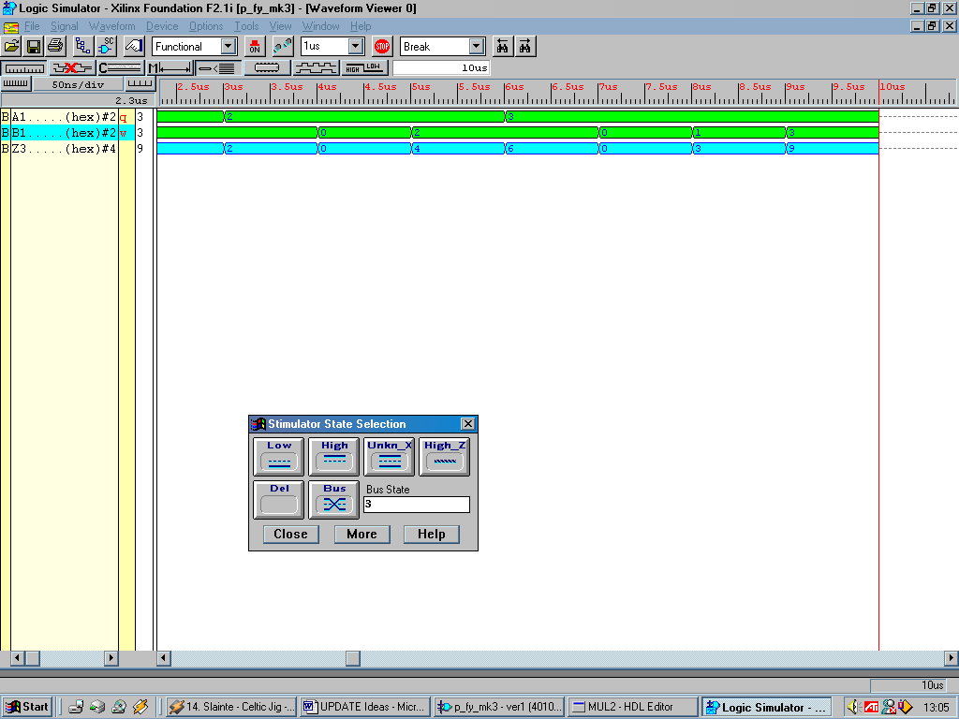
Figure 8 :Results achieved by the 2- bit multiplier named MUL2

Looking at Figure 8, the two input waveforms are shown in green, output of the entity shown in blue. Because inputs A1 and B1 are 2-bits wide, the maximum value available on one of these inputs is the value 3. Hence, because there are two inputs to this entity, the maximum value that can be obtained at the output is 9. The hexadecimal value 9 in binary is 1001, a four bit answer. Using a select number of different input combinations it can be seen that the output follows the input correctly.

ADD4
The 4-bit adder is required to add together two four bit values, the biggest addition it faces is 9+9. The answer 18 converted to binary is 10010, a five bit answer. If a behavioural model of the 4-bit adder were to be generated, when summing the two 4-bit operands, a 4-bit answer would be created, i.e. no carry would be generated. To avoid this problem, available in the VHDL syntax is a concatenation operator “&”. This allows data on the inputs to be bit width extended in order to be the same width as the required answer output. Hence two four bit numbers can be input, extended to five bit numbers, addition takes place, a five bit answer can then be outputted. The VHDL script that describes the behaviour of the 4-bit adder (Entity name “ADD4”) can be found in the appendix of this report.
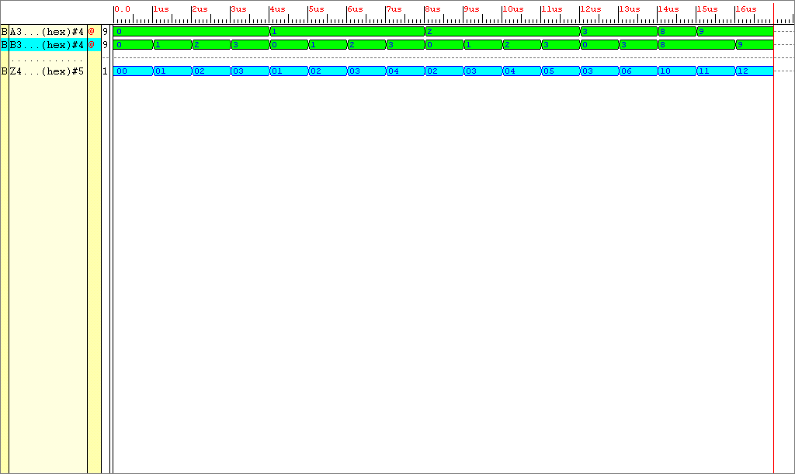
Figure 9: Results achieved by the 4-bit adder named ADD4

Looking at Figure 9, all outputs are represented in hexadecimal format. A3 and B3 are 4-bit inputs, when a range of 4-bit values are input to the Entity the corresponding 5-bit answer is output on output port Z4. As can be seen, the output follows the inputs, when the addition 9+9 takes place the corresponding answer is hexadecimal 12 which is equal to 10010, five bits wide.
As can be seen in each of the configuration schematics, after the arithmetic blocks (the adders and multipliers) a storage element exists which holds the value of the answer “product” matrix. The product is a matrix made up of 2 columns and 2 rows, a four element result. Because each sum of product result is 5-bits wide, and that there are four result elements in the matrix product, the total number of bits making up the product matrix will be 20. Hence the memory element would be required to hold 20-bits of data in each configuration.

2-BIT
MUL

2-BIT
MUL

2-BIT
MUL

2-BIT
MUL

2-BIT
MUL

2-BIT
MUL

2-BIT
MUL

2-BIT
MUL

2-BIT
MUL

2-BIT
MUL

2-BIT
MUL

2-BIT
MUL

2-BIT
MUL

2-BIT
MUL

2-BIT
MUL

2-BIT
MUL

2-BIT
MUL

2-BIT
MUL

2-BIT
MUL

2-BIT
MUL

A(2)B(1) + A(3)B(3)
A(2)B(0) + A(3)B(2)
A(0)B(1) + A(1)B(3)
A(0)B(0) + A(1)B(2)
4-BIT
ADDER
ASM CONTROLLER
CONFIGURATION_1
FD (19 DOWNTO 15)
FD (14 DOWNTO 10)
FD (9 DOWNTO 5)
FD (4 DOWNTO 0)

Figure 10: Schematic of the memory elements

The three configurations have three differing linkages between the output of their adders to the input of their memory elements. Taking for example Figure 10, this represents the storage situation in Configuration 1. Between it’s single adder and it’s memory elements there is one 5bit bus. Those 5bits of the bus are connected to 4, 5bit storage elements (required to store the complete matrix product). In order for data to be stored in a particular 5bit storage element, the controller must enable that particular 5bit storage element. Hence after four clock cycles, after each of the four 5bit storage element have been enabled in turn, the completed answer is ready and waiting on the memory elements outputs. Configurations 2 and 3 have two and four adders respectively, which corresponds to having two and four 5bit buses from the output of the adders to input of the storage element. With their larger bus structure, less clock cycles are required to produce and store data.
For each Configuration, the structure of the memory element is the same i.e. they have the same number of storage elements. However, their port structures are different, more inputs and outputs are required in Configuration 3 compared to Configuration 1 for example. With this in mind, it seems logical to test each of these configurations memory elements/systems in turn. When all systems work individually, then all three can be testing collectively. To start the ball rolling Configuration 1’s memory element will be tested.

Configuration 1 Testing

Figure 10 shows the structure of the memory elements of Configuration 1. The script that describes the behaviour of this entity (Entity name “Answer_Store”) is placed in the appendix of this report.
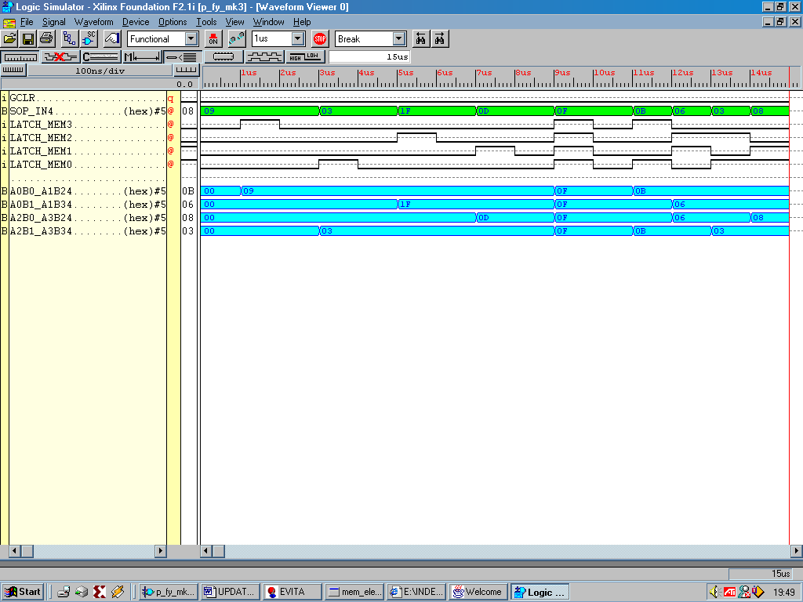
Figure 11: Simulation results showing the behaviour of entity Answer_Store

From the output of the adder (the adder is not involved in the testing of this entity) there is a 5bit bus. In the above simulation results it is named “SOP_IN4”, which basically means sum of products. Inputs GCLR and Latch_Mem 0 to 3 are all 1-bit inputs. When GCLR is high the output of the memory elements (A0B0_A1B24…A2B1_A3B34) goes low. When GCLR is low, dependant on the value of the select signal “Latch_Mem” the input data will be directed to the output of the corresponding 5bit storage element (A0B0_A1B24…A2B1_A3B34). This behaviour can be seen in Figure 10.
The individual components which make up the digital signal processing unit i.e. multipliers, adders and storage elements, simulate correctly. Grouping together these elements to create one individual DSP for Configuration 1 would tidy up logic and introduce a higher, easier to understand level of abstraction.

DSP – Answer_Store, ADD4, MUL2

The script that describes the behaviour of the entity (Entity name “DSP”) is placed in the appendix of this report.

A problem arose from connecting all the separate DSP entities together. When performing a syntax check on the entity DSP, an error occurs. The multiplier requires data type, UNSIGNED at it's inputs, which creates an UNSIGNED output. The adder and memory element operates on data of type STD_LOGIC. By searching through the Xilinx Foundation 2.1i help website, such a converting function was found:

CONV_STD_LOGIC_VECTOR(ARG: UNSIGNED; SIZE: INTEGER) return STD_LOGIC_VECTOR;

The function shown above in it’s general form converts an UNSIGNED data element into a STD_LOGIC_VECTOR made up of a specified number of bits. By updating the entity MUL2, to incorporate this function (new multiplier entity described in the appendix of this report) the DSP can now be realised.
Before the DSP could be tested, how would the data enter it. Data could easily be shifted in a serial manner then acted upon by the DSP. Because the whole purpose of this project rested on the aspect of exploiting parallelism, data should also share this aim. So the matrices data will arrive at the input to the DSP in parallel, but where from? The easiest method, the method which is adopted, is the use of a memory element (ROM) prior to the DSP. In the realisation of this entity, data control signals would be sent from the ASM CONTROLLER to the memory module. Data in this memory module would then be placed on the data bus when required. To visualise the operation of the Configuration 1 system so far, a schematic has been prepared.

LATCH_MEM SIGNAL
std_logic_vector
(3 downto 0)
ELEMENT DATA BUS
unsigned (7 downto 0)

DATA SELECT SIGNAL
Integer range (3 downto 0)
CLR

CLK

ASM CONTROLLER
CONFIGURATION_1

DSP

MEMORY
BLOCK
A0B0_A1B2
std_logic_vector
(4 downto 0)
A0B1_A1B3 std_logic_vector
(4 downto 0)
A2B0_A3B2
std_logic_vector
(4 downto 0)
A2B1_A3B3
std_logic_vector
(4 downto 0)

Figure 12: High Level Abstraction of the Configuration 1 System
All that's left for the controller to do is generate the appropriate control signal to the DSP and memory storage so that the device operates correctly, with control. Before Delving into the Controller design, the DSP and Matrix memory storage “Data_Store” need to be generated then simulated.
As described previously in this report, two, 2x2 matrices of known element magnitude are to be multiplied together. Entity Data_Store, a ROM, has, stored in four sets of 8-bit arrays the data required to complete one matrix product. However for this architecture the data is arranged in such a way shown and described below.

11 10 01 11

- TOUGH TO DESCRIBE, COME BACK TO THIS

The VHDL script that describes the behaviour of entity Data_Store can be found in the appendix of this report.
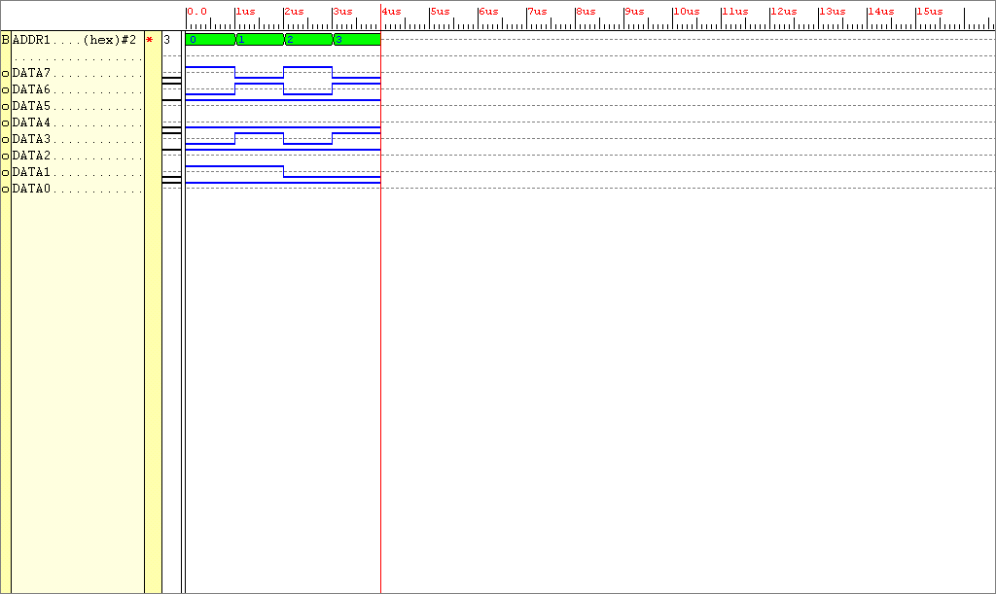
Figure 13: Simulation results achieved by Entity DATA_STORE

The beauty to the design of the entity Data_Store is it’s simplicity. Dependant on the value of the select signal ADDR, the appropriate eight bits of data will be inserted onto the data bus. As can be seen signal ADDR is a 2bits wide hence 4 selections of data are available to be outputted, corresponding to the four sets of multiplications required to be calculated by Configuration 1.
The entity Data_Store operated in the correct manner. Before the finite state machine can be created, the matrix data storage will need to be tested with the DSP. The VHDL script that describes the behaviour of this ENTITY can be found in the appendix of this report.

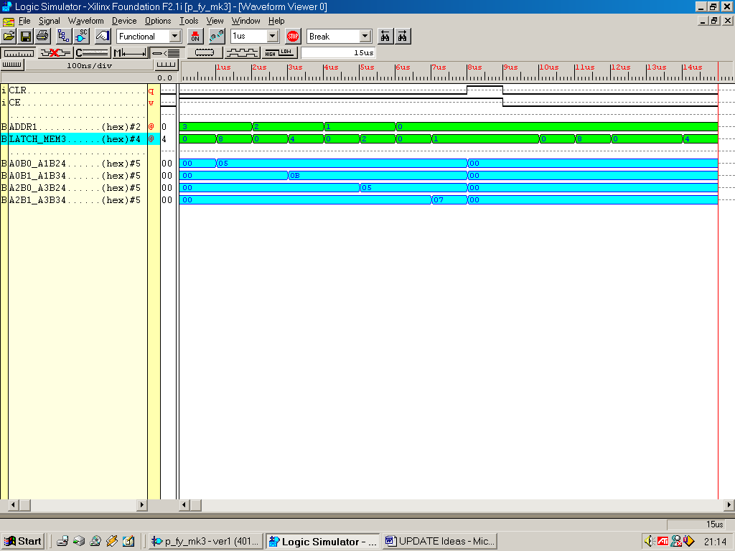
Figure 13: Simulation results achieved by Entity MEM_DSP

Ignoring the clock enable “CE” signal again. When the signal CLR is low the inputs shown in green can operate. If input latch_mem is 8 (binary 1000), the first set of 5bit storage elements are enabled and the data stored (in the case of this example) address 3 appears on it’s outputs. If input latch_mem is 4 (binary 0100), the second set of 5bit storage elements are enabled and the data stored (in the case of this example) address 2 appears on it’s outputs. To enable the 3rd, then 4th set of latches addr values of 1 and 0 are input to the Entity respectively.
The finite state machine, the controller of the system is not very complex at all. It is required to select the correct data from the Data Storage Entity. It then must enable the correct Answer Storage element to holds the matrix products. The VHDL script that describes the behaviour of this system can be found in the appendix of this report.

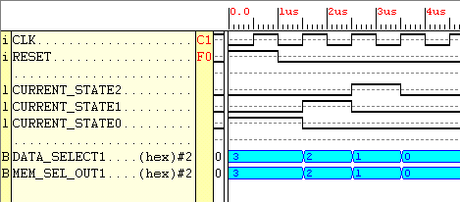
Figure 14: Simulation results achieved by Entity ASM_CONFIG_1.

This state machine has four different states. When reset is high the output select signals are initialised to a hex 3. When reset is low and a rising edge on the clock occurs the current state cycles until the final state is reached. Any additional rising edges of the clock do not alter the output from the finite state machine.
The complete system Configuration 1 can now be created and simulated. The
The VHDL script that describes the structure of its architecture can be found in the appendix of this report.
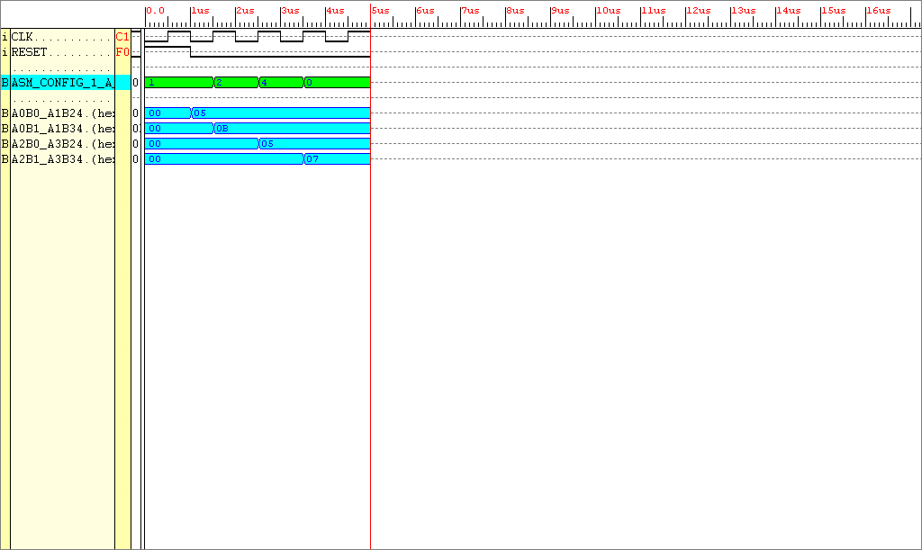
Figure 15: Simulation results achieved by Entity Configuration_1

Figure 15 shows the system in full operation. In accordance with the state of the system, an elemental matrix product is produced which is output to the correct set of 5bit memory elements. These are marked down on the simulation above as A0B0_A1B2 to A2B1_A3B3.
For a multiplication to take place four clock cycles are required.
To give the VHDL script a more accessible layout, a package was produced. The finalised package is placed in the back of this report.

Configuration 2 Testing
The digital signal processing part of this configuration is easily constructed from Figure 6, the individual components that make up this system have been created for the previous configuration. The controller ASM_CONFIG_2 however will be tested. The VHDL source file which generated these results can be found in the appendix of this report.
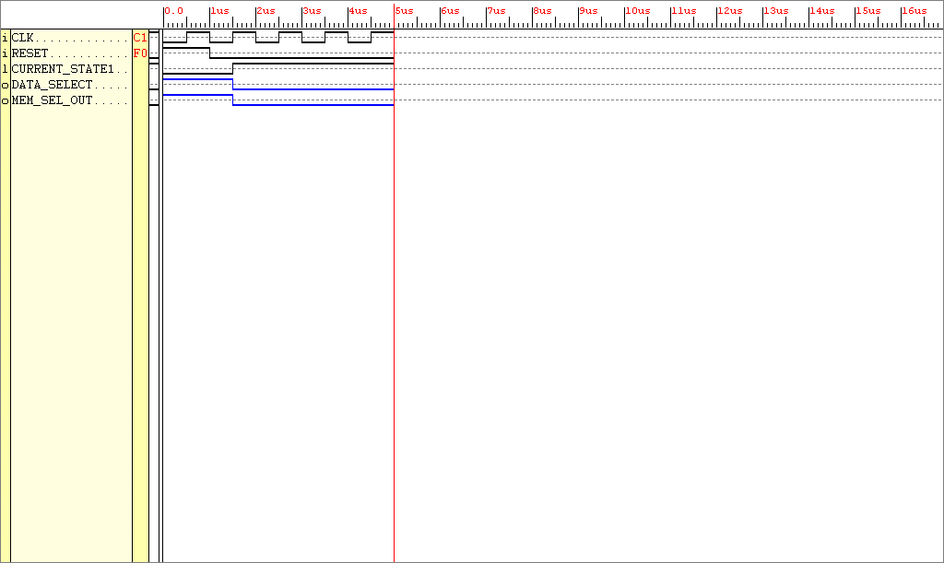
Figure 16: Simulation results achieved by the finite state machine ASM_CONFIG_2.

Looking at Figure 16, the controller is very simple. Reset initialises the state. In the first state signals Data_Select and Mem_Sel_Out are high, in the second state Data_Select and Mem_Sel_Out go low.
Join the respective parts (ASM, Element Store, DSP) together using structural VHDL.
Here are the results of the whole system performing. The file that describes the structural layout of the entity can be found in the appendix of this report.
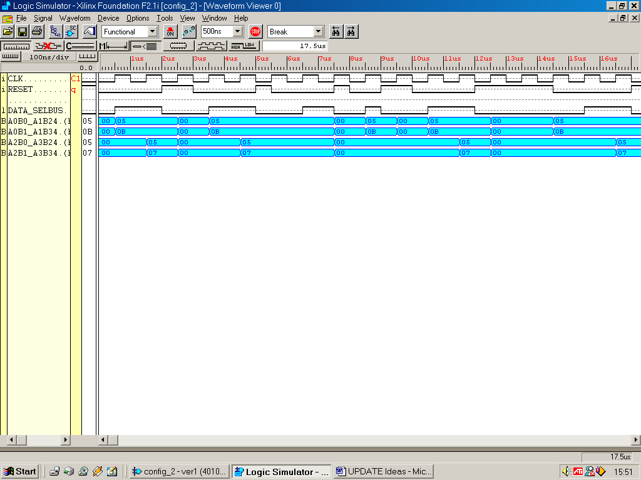
Figure 17: Simulation results achieved by Entity System_2.

In the first state half the data required for the matrix product is selected to be entered onto the data bus using the select signal “Data_Select.” 10bits of answer memory are enabled using the select signal “Mem_Sel_Out.” In the second state, both select signals go low, the second half of data is placed onto the data bus. The final data bits are placed onto the data bus, the DSP acts upon these data bits to create the matrix product for the last two elements.
Notice it takes 2 clock ticks to complete the matrix multiplication operation.

Configuration 3 Testing
Configuration 3 has a much bigger DSP structure than the previous configurations. This system doesn’t require much in terms of control signals to make it run. All the matrix data required to complete the two, 2x2 matrix multiplication can be entered straight onto the data bus input to the DSP. Because the DSP can handle the arithmetic operation on all the matrix data, the complete answer is ready to be stored without any further calculations. The indivdual components are not tested here, however the full system is. To observe the structure of ENTITY Configuration_3 look in the appendix of this report.

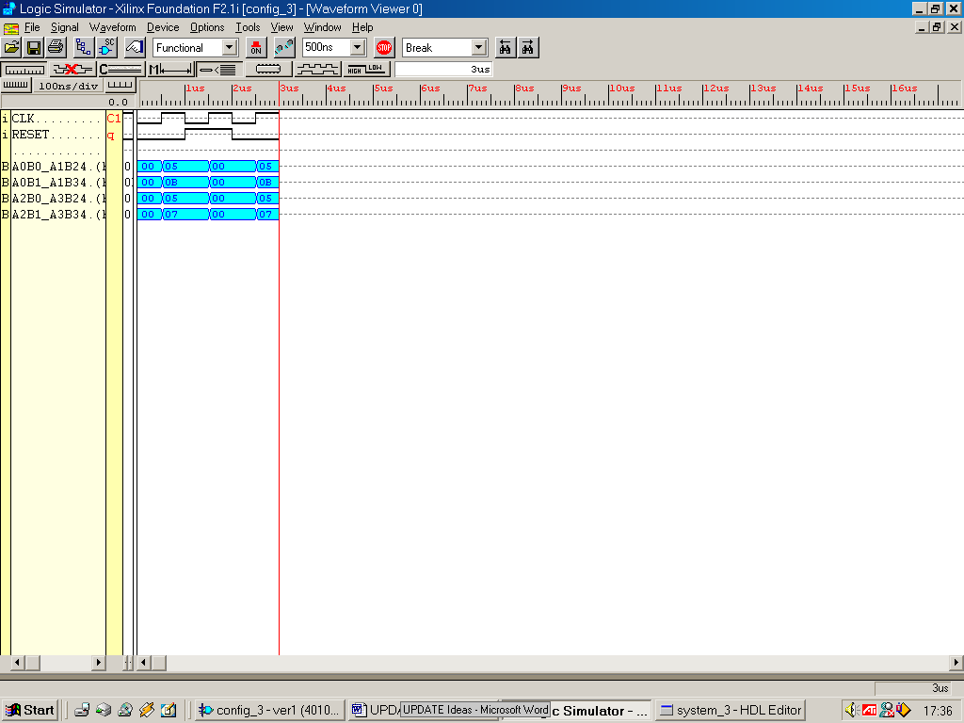
Figure18: Simulation results achieved by Configuration_3

There has been a large number of steps involved in creating the 3 initial Configurations. The three configurations work individually, collective testing is required to create a system which shows in one test cycle, the results of exploiting parallel architectures. The system that has three configurations collectively will be called Configurations 123.

Configurations_123 Testing
To observe the structural VHDL of ENTITY Configuration_3 look in the appendix of this report.

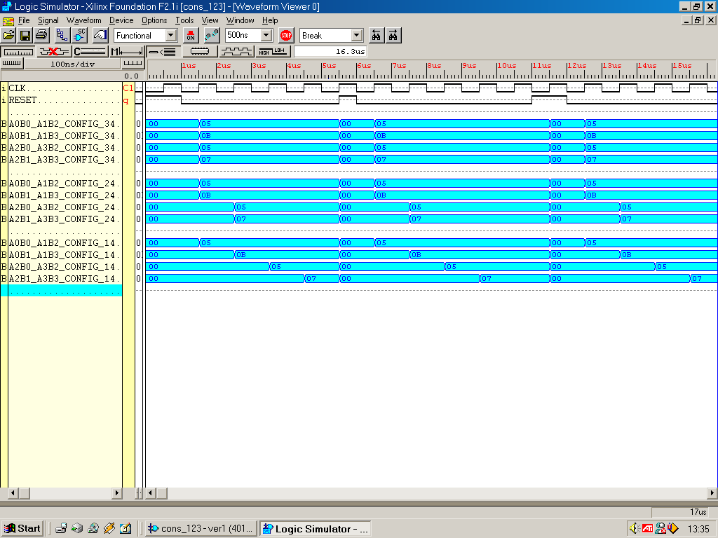
Figure19: Simulation results achieved by ENTITY Systems_123

The results are shown above in blue, Configuration_3 results are shown in the four uppermost blue bands, Configuration_2 results are shown in the middle set of bands and Configuration_1's results are shown in the bottom blue band. The system must always be initially RESET to initialise the current state. These results clearly show the advantage of having a parallel architecture.
The next step after the process of design, synthesis and evaluation is implementation. The target hardware for the design is a Xilinx XC4010XL PC84 FPGA. Using the Xilinx Foundation Series Software, by pressing the implementation button on the design flow manager, the library models are converted into a net list which is then validated for mapping, placing and routing. However the ENTITY Configurations_123 could not be placed and routed because all the external IOB were used up. A solution, bus re-use, there are too many large buses used within this matrix multiplier design. If some buses could be reused, or used to handle other data which it wasn't designed for then there will be a saving in the total amount of IOB's used.
It is known that the whole system operates correctly in simulation, but cannot fit onto the target FPGA due to the masses of large buses required by the system. If the system was integrated, with an emphasis on bus re-use, could the system be built efficiently, to give the correct results?

Design Thoughts
ASM Controller- Integrate the ASM controllers into one Architecture. Only one configuration would be able operate at any one instant. Hence the amount of states required to justifiably create this would have the accumulative amount of states of the three individual configurations.

Memory Block - Integrate all the memory elements into one large ROM, remembering to use different processes for the different Configurations.

DSP - If the amount of multipliers and adders are kept to that used in configuration_3 all configurations can be accounted for, saving valuable extra buses in the process. However, the ENTITY memory must be changed in order to allow for 3 different types of SOP output.

Note the answer storage must operate in total 7 different ways to account again for the separate configurations. For example store answer using 20, 10 or 5 of answer memory. The required select signal needs to be 3 bits wide to cater for these seven operations. With these thoughts in mind the initial integrated configurations can now be visualised.
32-BIT
Elemental Data Bus

ASM CONTROLLER

EIGHT 4-BIT DATA BUSES

DATA
STORE
S 3bits
Configuration Mode Select
2-BIT
MUL

FOUR 5-BIT DATA BUSES HOLD SOP. THIS DATA IS THEN PLACED
MEMORY SELECT
SIGNAL 3-BITS WIDE

ON A 20-BIT BUS WHICH ENTERS THE ANSWER STORAGE

A(0)xB(0) + A(1)xB(2)

A(0)xB(1) + A(1)xB(3)

A(2)xB(0) + A(3)xB(2)

Matrix B
Data Element
DATA SELECT SIGNAL
Integer range (6 downto 0)
Matrix A
Data Element
Matrix B
Data Element
Matrix B
Data Element
Matrix A
Data Element
Matrix A
Data Element
Matrix B
Data Element
Matrix A
Data Element
Matrix B
Data Element
Matrix A
Data Element
Matrix B
Data Element
Matrix A
Data Element
Matrix B
Data Element
Matrix A
Data Element
Matrix B
Data Element
Matrix A
Data Element
A(2)xB(1) + A(3)xB(3)
2-BIT
MUL

4-BIT
ADDER

ANSWER
STORE
STORES FOUR SETS OF SUM-OF PRODUCTS
4-BIT
ADDER

2-BIT
MUL

2-BIT
MUL

2-BIT
MUL

2-BIT
MUL

2-BIT
MUL

2-BIT
MUL

4-BIT
ADDER

4-BIT
ADDER

ALLOCATE DATA TO MEMORY LOCATION
1, 2, 3 OR 4

Figure20 : High Level Abstraction of the Configuration Integrated System
Configuration_Integrated
Shown below is some arbitrary test data used on the system

2
1
0
1
1
2
1
0

MATRIX_1 MATRIX_2

The multiplication and addition operations performed will be :-

(2 x 1) + (1 x 1)
(2 x 2) + (1 x 0)
(0 x 1) + (1 x 1)
(0 x 2) + (1 x 0)

Line these numbers out in a row (remove all mathematical symbols), in a top to bottom, order we have:-
2 1 1 1 2 2 1 0 0 1 1 1 0 2 1 0

if these numbers are then coupled, corresponding to 2 numbers per multiplier we have:-

2 1, 1 1, 2 2, 1 0, 0 1, 1 1, 0 2, 1 0

Convert these numbers into their binary equivalent:-

10 01, 01 01, 10 10, 01 00, 00 01, 01 01, 00 10, 01 00

This is the matrix arithmetic data in binary format ready to be processed by the multipliers.

Operation of the system (refer to Figure 20)

An input to the ASM controller called input (S) will be used to select between the three Configuration modes.

When the finite state machine is ordered to work in MODE Configuration_1:-
When the state machine is RESET i.e. in its initial state, the initial byte of the matrix data will be placed on bits(0-7) of the ELEMENTAL_DATA_BUS. These bits correspond to the input data required to achieve the first of the four product elements. Next clock tick occurs, state machine moves to the next state, the next byte of the matrix data is then placed on bits(8-15) of the ELEMENTAL_DATA_BUS. After two more clock ticks all the data has been passed to the DSP, processed and outputted.

When the finite state machine is ordered to work in MODE Configuration_2:-
When the state machine is in its initial state (after being RESET) a word of the matrix data is placed on bits(0-15) of the ELEMENTAL_DATA_BUS. The next clock tick occurs, the state machine enters the next state, the next word of the matrix data is placed on bits(16-31) of the ELEMENTAL_DATA_BUS. All the data has been passed to the DSP, processed and outputted.

When the finite state machine is ordered to work in MODE Configuration_3:-
When the state machine is in its initial state, a long word is placed on the full width, bits (0 – 31) of the ELEMENTAL_DATA_BUS. All the data will be processed in the initial state i.e. no further states, clock ticks required to process data.

The MSB of the data is placed on
In Configuration_1
- bit 7 of the ELEMENTAL_DATA_BUS in initial state S0
- bit 15 of the ELEMENTAL_DATA_BUS in state S1
- bit 23 of the ELEMENTAL_DATA_BUS in state S2
- bit 31 of the ELEMENTAL_DATA_BUS in state S3

In Configuration_2
- bit 15 of the ELEMENTAL_DATA_BUS in initial state S0
- bit 31 of the ELEMENTAL_DATA_BUS in state S1

In Configuration_3
- bit 31 of the ELEMENTAL_DATA_BUS in initial state S0

Only one answer will be outputted at any one time. Three separate answers for the three modes of operation will not be adopted due to the limiting factor of pins available.

Configurations_Integrated Testing

Now that the initial realisation of the design phase of Entity Data_Store is now complete the behavioural model of the system can be created in VHDL and simulated. The behaviour model of ENTITY Data_Store can be viewed in the appendix of this report.
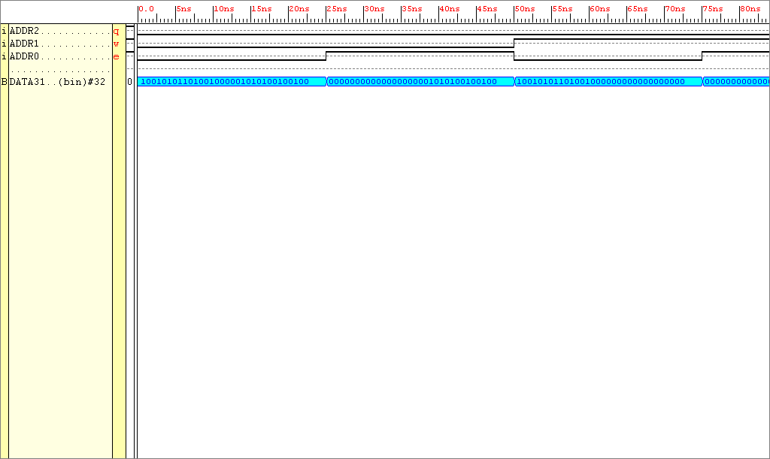
Figure21 : Partition of the simulation results for entity Data_Store

Looking at Figure21, when the signal entering the ROM into the input Addr is decimal 0, the ROM works in Configuration 3 mode. All the matrix arithmetic data (all 32-bits of it) is placed onto the Elemental_Data_Bus. When the signal entering the ROM into input Addr is decimal 1, the ROM works in Configuration 2 mode, data (lower 16-bits) is placed onto the Elemental_Data_Bus. When the signal entering the ROM into input Addr is decimal 2, the ROM works in Configuration 2 mode, data (upper 16-bits) is placed onto the Elemental_Data_Bus

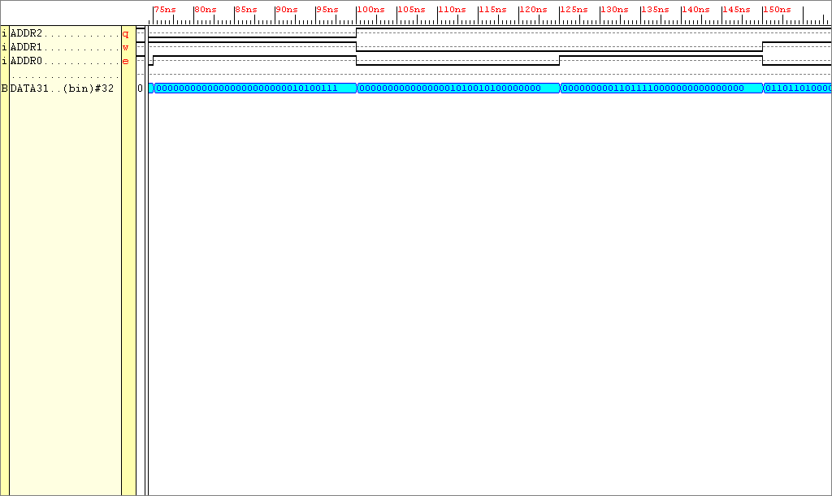
Figure22 : Partition of the simulation results for entity Data_Store

Looking at Figure22, when the signal entering the ROM into port Addr is 3 Config_1’s data (lower 8-bits) are placed onto the Elemental_Data_Bus. When the signal entering the ROM into port Addr is 4 Config_1’s data (bits 15 downto 8) are placed onto the Elemental_Data_Bus. When the signal entering the ROM into port Addr is 5 Config_2’s data (bits 23 downto 16) are placed onto the Elemental_Data_Bus.

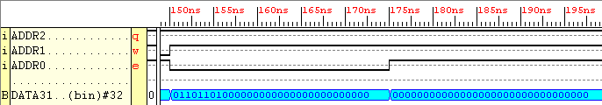
Figure23 : Partition of the simulation results for entity Data_Store

Looking at Figure23, when the signal entering the ROM into port Addr is 6 Config_1’s data (upper 8-bits) are placed onto the Elemental_Data_Bus. When the signal entering the ROM into port Addr is 7 nothing is placed onto the Elemental_Data_Bus (or just plain rubbish!).

The other entity that requires re-designing in order to compensate for the three configurations is ANSWER_STORE. The Select line input to the ANSWER_STORE entity will need to be 3-bits in width due to the 7 modes of operation required. These are:-

Four modes to Store 4 eight bit values in 4 cycles
Two modes to Store 2 sixteen bit values in 2 cycles
One mode to Store 1 thirty two bit value in 1 cycle

One select mode will not be required (7 are required out of a possible 8), the answer store will be ordered to output zeros in this case.
The behaviour model of ENTITY Answer_Store can be viewed in the appendix of this report.

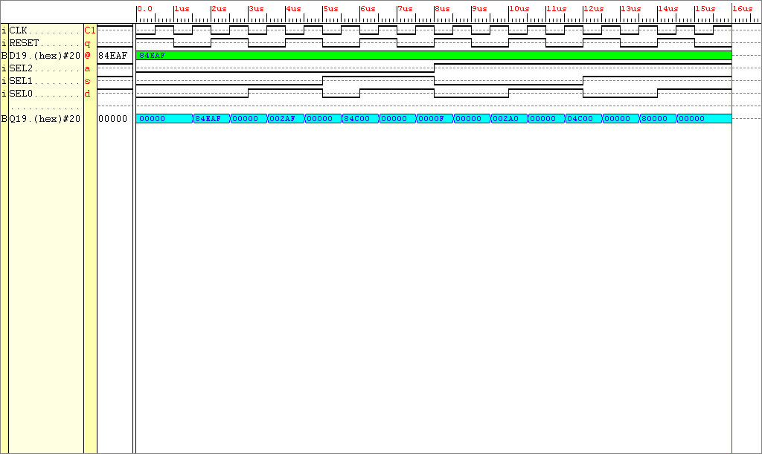

Figure24: Simulation results for Entity Answer_Store

Evaluation of Results
When RESET is low and the rising edge of the clock occurs:-
When select is HEX 0, the 32-bits of D are outputted onto Q
When select is HEX 1, the lower 16-bits of D are outputted onto Q
When select is HEX 2, the upper 16-bits of D are outputted onto Q
When select is HEX 3, the lower 8-bits of D are outputted onto Q
When select is HEX 4, bits (15 downto 8) of D are outputted onto Q
When select is HEX 5, bits (23 downto 16) of D are outputted onto Q
When select is HEX 6, the lower 8-bits of D are outputted onto Q
When select is HEX 7, all 0’s are outputted onto Q

The next subsystem to create and evaluate is the finite state machine. The finite state machine is responsible for enabling the memory blocks in order to input data to and output data from the DSP.

Three separate finite state machines of Configuration’s 1,2 &3 need to be incorporated into one entity. In order for a common platform to be shared, these three separate state machines must share a common initial state. The behaviour model of ENTITY ASM_Controller can be viewed in the appendix of this report.

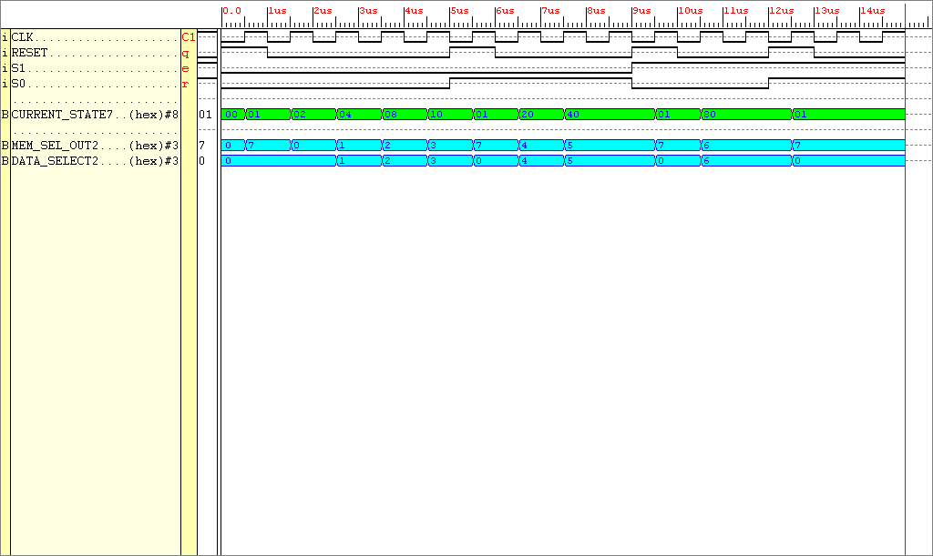
Figure25: Output from ENTITY ASM_CONTROLLER

Evaluation of Results - When the system is RESET the controller enters it’s initial state. When the value of S (the Configuration Selector) is at decimal ‘00’, the finite state machine outputs after four clock ticks all the correct select signals for the system to emulate Configuration 1. When the value of S (the Configuration Selector) is at logic ‘01’, the finite state machine outputs after two clock ticks all the correct select signals for the system to emulate Configuration 2. When the value of S (the Configuration Selector) is at logic ‘10’, the finite state machine outputs after two clock ticks all the correct select signals for the system to emulate Configuration 3.

The complete system can now be built, the other DSP subsystems are taken from the Configuration 3 design and manipulated to work with this system.
The matrix product result is taken from the example presented at the start of this section (page 34).
(2 x 1) + (1 x 1) = 2 + 1 = 3
(2 x 2) + (1 x 0) = 4 + 0 = 4
(0 x 1) + (1 x 1) = 0 + 1 = 1
(0 x 2) + (1 x 0) = 0 + 0 = 0

3 4 1 0

The whole system will now be tested. The behaviour model of ENTITY Whole_System and the DSP (which is incorporated in the Whole_System) can be viewed in the appendix of this report.
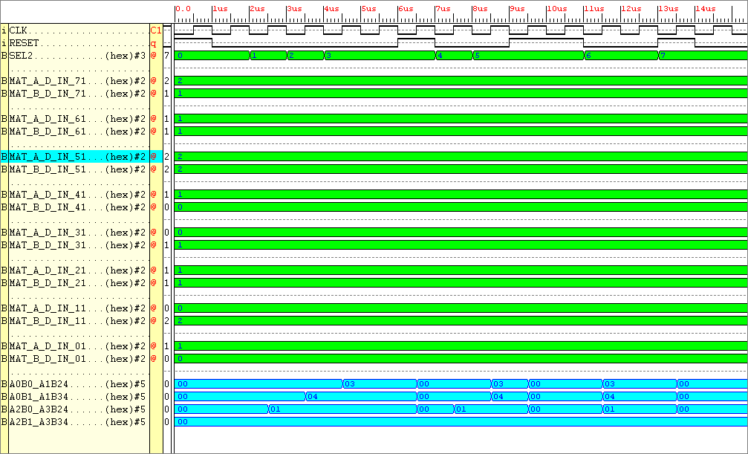
Figure26 : Simulation results for the Entity DSP

Observe the results at the bottom of the figure in blue (these are the outputs from the DSP). The answers calculated on page 39 correlate exactly with the simulation results in Figure26. The results span over seven states. In mode Configuration 1 output an answer take 4 cycles, whilst the faster Configuration 3 only takes one cycle. Each set of results are separated by a RESET, so that the next multiplication mode’s outputs can be seen (the results obtained in all three modes are the same, without a zeroing of the output signals, the calculated values on the outputs would not be seen).
Using the Xilinx Foundation Series Software, the design could now be implemented. The FPGA place and routing software, without error, produced files which contained all the data required to program the FPGA. By using the program Floorplanner within the Xilinx Foundation suite, the structure of the design within the FPGA could now be viewed.

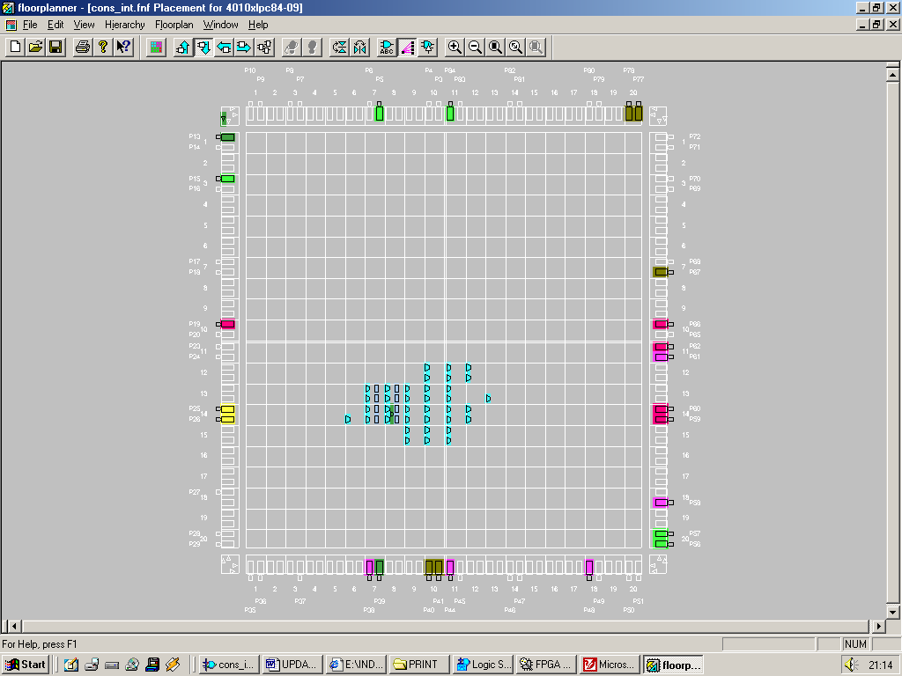
Figure27 : Design structure of the integrated Configurations within the FPGA

The floorplan view of the design clearly shows it can clearly be routed and programmed in the FPGA. Now that that this simple system works (simulates and can be placed and routed) a few things can be done to increase the complexity of the design. Still keeping with the format “the maximum magnitude of a matrix element is 3”, by upping the size of the matrix data. The ENTITY DATA_STORE will need to include more data, the multipliers and adders can be kept in tact ENTITY ANSWER_STORE will need to be more complex in order to store more data, also the ASM_CONTROLLER will require more states and steering logic. So now the best thing to do is start a new project, upping the complexity of the old one.

Matrix multiplication of two 4x4 matrices was researched, tested but not implemented. After some serious thought, to output the product of two 4x4 matrices would require too many complex logic blocks which are simply not available. 290 CLB’s are taken up by the DSP alone.

The 3x3 Matrix Project

After ruling the out the requirement for a matrix multiplier that multiplies two 4x4’s what can be done however is to produce a system that produces the product of two 3x3 matrices. Producing the DSP that will calculate the matrix products would be a simple task, because it is a scaled down version of the 4x4 matrices. Another problem to overcome was data input, the thought of using the onboard RAM on the XS40 board was an option, but the procedure required to access it seems too complex a task. A better way would be to use a program which is part of XSTOOLS which allows a windows based simulation program that allows data to be input to the board through the parallel port in eight-bit quantities.
A13
A23
A11
A12
A21
A22
A31
A32
A33
B13
B23
B11
B12
B21
B22
B31
B32
B33

MATRIX_A MATRIX_B
Figure28 : Mathematical representation of the matrices

(A11 x B11) + (A12 x B21) + (A13 x B31)
(A21 x B11) + (A22 x B21) + (A23 x B31)
(A31 x B11) + (A32 x B21) + (A33 x B31)

(A11 x B12) + (A12 x B22) + (A13 x B32)
(A21 x B12) + (A22 x B22) + (A23 x B32)
(A31 x B12) + (A32 x B22) + (A33 x B32)

(A11 x B13) + (A12 x B23) + (A13 x B33)
(A21 x B13) + (A22 x B23) + (A23 x B33)
(A31 x B13) + (A32 x B23) + (A33 x B33)

By looking at the methodology for solving a 3 x 3 matrix it can be seen that 27 multiplications are involved. Also for every 3 multiplication operations 1 adder is required.

NUMBER OF MULTIPLIERS REQUIRED = 27
NUMBER OF ADDERS REQUIRED = 9

There are 18 elements involved in a 3x3 by a 3x3 matrix multiplication, each element is limited to a 2-bit value hence

BITS OF INPUT DATA = (No. of elements in MATRIX_A + No. of elements in MATRIX_B) x (Bit width magnitude of a elements data)
BITS OF INPUT DATA = ((3x3 )+ (3x3)) x 2 = 36 bits

If all the elements had a magnitude of 3 (highest case) then the magnitude of an element of the product matrix would be

(A11 x B11) + (A12 x B21) + (A13 x B31)
(3 x 3) + (3 x 3) + (3 x 3)
9 + 9 + 9 = 27, twenty seven in binary is 11011, which is 5-bits wide

The magnitude of each matrix elements product would be 5-bits, there are 9 products, hence the answer would be 45-bits wide.

In the previous Integrated Configuration system data was stored in the system in a block of ROM. This block of ROM cannot be written to, the input data held once created cannot be altered. To fulfil an aim, it would be allot more satisfying for the user to input his or her own matrices data. As explained earlier, this can be done by inputting data using the parallel port cable into the FPGA. But how will the data be stored in the FPGA?

By using a program called WinXSport, data can be downloaded to the XS40 board through the PC Parallel port. Eight bits of data can be downloaded at any one time.

There are 36 latches available to send data to, the correct set of latches needs to be selected, hence in the byte of data is latch select information. What can be done is, send data in nibbles, which leaves 4-bits remaining to select which set of latches the data needs to be sent to. 36-bits of data needs to be sent to the latches in total, 4-bits of data can be sent per cycle, hence 9 data cycles are required to send the 36-bits of data. 9 different select signals, a 4-bit select signal is required to coordinate the data destination. Hence:-
In the byte of data sent from the WinXsport program there are:-

- 4-bits of signal select
- 4-bits of data

Hence the ENTITY DATA_STORE will have a 8-bit input, 4bits used to input data the remaining 4bits selects the correct latches of the entity input. There is a 36-bit matrix data output that handles the answer output. Problem, From simulating the initial system (VHDL script withheld from the report) the output of latches refuse to reset. Solution, have a clock input on the PC Parallel port data byte, have 4-bits of that byte devoted to flip flop (not latch) selection, 1- bit of the byte devoted to a clock signal, and the remaining 3-bits devoted to data transfer. Lets look at the wider implications of this new entity design. In the byte of data sent from the WinXsport program there are:-

4-bits of signal select
1-bit parallel port clock signal
3-bits of data

Hence the ENTITY DATA_STORE
INPUT : 3-bits input data
1-bit clock input
4-bits select input
OUTPUT: 36-bit matrix data output

There will be 36 D-type flipflops involved in the data transfer, if the rising edge of the clock signal occurs, dependant on the select signal, 3-bits of input data is transferred to the output of three flip-flops. Hence 12 clock ticks are required in order to get all the data onto the Elemental Data Bus as opposed to 8, as in the previous design. Here’s how data will look on the parallel port WinXsport program interface.

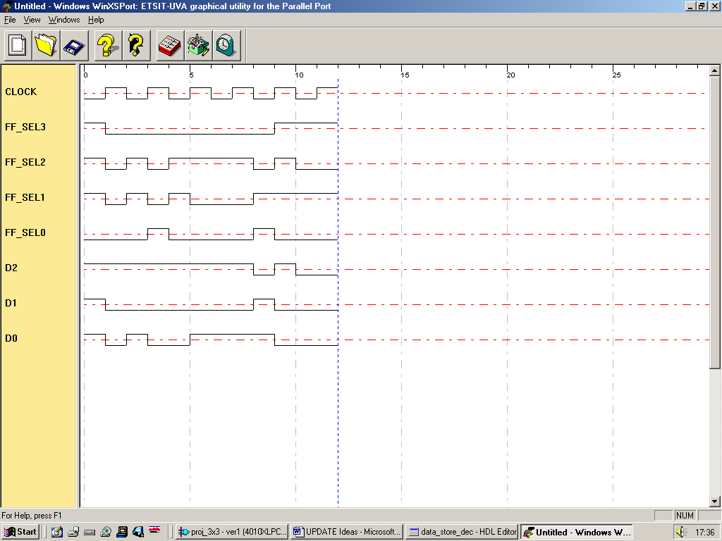
Figure 29: Screen capture from the XS40 simulation tool WinXSport showing clock, select and data signals

The Data Store algorithm will now be created which will allow (stable) flip flops to be used in place of (unstable) latches. The behaviour model of ENTITY Data_Store can be viewed in the appendix of this report.

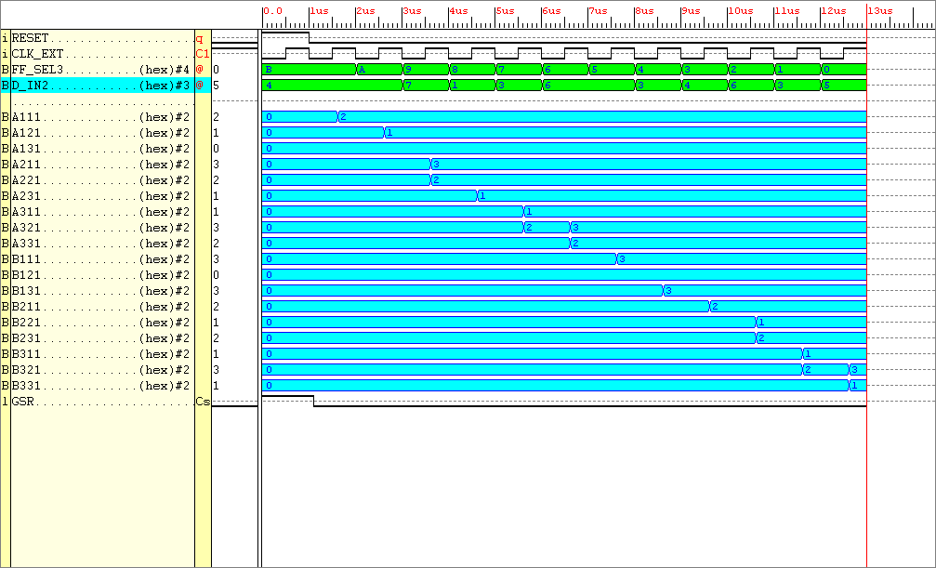
Figure30 : Simulation results for the new clock driven Entity Data_Store

Observing the data above it can be seen that (governed by the external clock “clk_ext”) the correct data is outputted from the system. The data in D_IN is 3-bits wide, it is at a value of 7 for this simulation (binary “111”), using the 12 select signals “FF_SEL” the data goes to the correct set of flip-flops.

There were 2 WARNINGS inferred when implementing (software place and routing) the synthesised model. After visiting the Xilinx website it was clear that these warnings were caused by a software fault. However the system behaved correctly. Notice there is no RESET input signal. This hasn’t been implemented mainly due to lack of pins on the parallel port. A reset will need to be implemented in later designs.
The implementation report indicates that this entity only requires 6 complex logic blocks, there are 400 available, hence this is a very small part of the overall system. In order to output data from the Entity “Data_Store” of type unsigned, the input data must also be of the unsigned data type. Cannot convert an object of STD_LOGIC_VECTOR into UNSIGNED, SIGNED, INTEGER type. Now the next process can be completed.

The entity used to multiply two 3x3 matrices requires 27 two input (2bit) multipliers. With each multiplier assigned it’s own unique combination of the input matrices elements. Lower order matrices can be multiplied together using this same architecture, however some of the multipliers will be redundant in this case. The behaviour model of ENTITY Data_Store can be viewed in the appendix of this report.
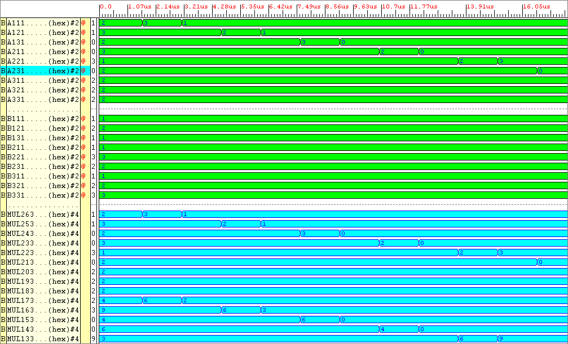
Figure31 : Simulation Results for the entity Multipliers

The A and B inputs (shown as a green waveform) are indexed from 11 to 33. For example, A11 refers to Matrix A, element position row 1, column 1.. The output waveform Mul26 (there are 27 multiplications involved in a 3x3 matrix product answer) refers to the very first product A11 x B11 (Mul0 is the last, but is not shown) shown in the simulation results. Page 42 shows the other 26 multiplications needed to produce the products ready for the adder section of the DSP to sum. The matrix B element coefficients were kept constant (at a value in the range 0 to 3) whilst the Matrix A values were altered. The answers achieved by the entity were true to the behavioural VHDL design. Knowing the entity performed true to it’s design it was then placed and routed using the Xilinx Foundation Software. This allowed further analysis such as FPGA routing constraints, and physical size determination. The multiplier entity required 54 complex logic blocks.

The adder entity will require 9 adders which consist of 3, 4bit inputs and 9, 5bit outputs. This allows all the products produced by the multiplier entity to be summed resulting in the matrix product. A very high level behavioural adder model is used, there is a concatenation operator which allows the carry bit to be produced. The behaviour model of Entity Adders can be viewed in the appendix of this report.
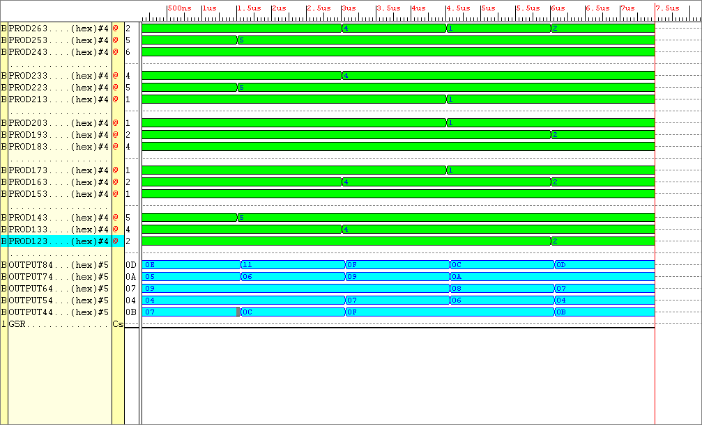
Figure32 : Simulation results from ENTITY Adders

To simulation results of Figure32 can easily be evaluated. Not all the inputs and outputs are shown here. The additions required are divided into groups of three, OUTPUT8 corresponds to the sum of the first set of three numbers, OUTPUT7 corresponds to the output of the second set of sums and so on. The outputs shown in blue at the bottom of the simulation results are in hexadecimal format. The first three additions at inputs PROD 26 downto 24 produced the answer “OE” at Output8, which corresponds to a decimal value of 14. Knowing the entity performed true to it’s design it was then placed and routed using the Xilinx Foundation Software. This allowed further analysis such as FPGA routing constraints, and physical size determination. The multiplier entity required 51 complex logic blocks.

The final part of the DSP which is used to store the outputted data is an Entity called Answer_Store. This entity just outputs what’s on it’s inputs on the clock edge, when enabled.
The behaviour model of Entity Answer_Store can be viewed in the appendix of this report.

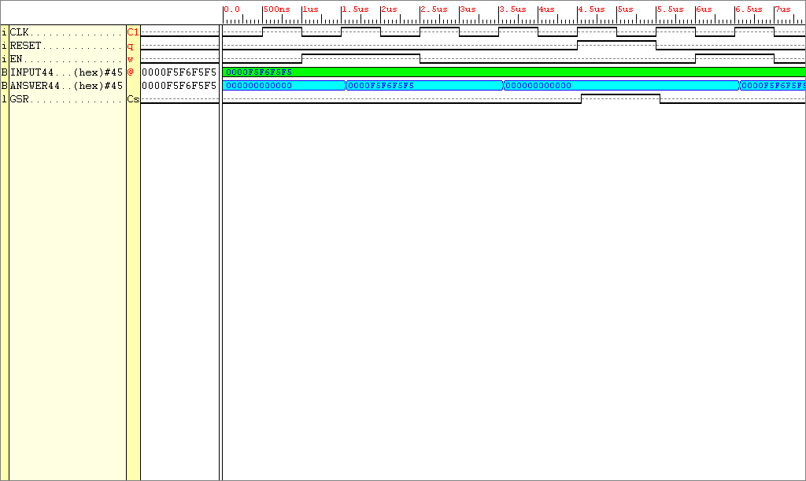
Figure33: Simulation results taken from entity Answer_Store

Because the signal Enable needs to be tied down to a particular value, it does act like a RESET signal. This however will not affect the behaviour of the system too much, the enable signal will just have to be kept high through the process of generating an answer. Once the data is stored on the board with the seven segment displays, the enable signal can then be taken off. Knowing the entity performed true to it’s design it was then placed and routed using the Xilinx Foundation Software. This allowed further analysis such as FPGA routing constraints, and physical size determination. The adders entity required 23 complex logic blocks. The DSP is completed up to a point, further processing is required in order for the matrix product answer to be outputted to the seven segment displays (more on this later).
A mechanism is required that allows the processing power for the serial and parallel architectures to be analysed. The most simple and one that comes to mind almost immediately is the idea of using a counter to calculate the clock cycles required to process the matrix data dependant upon the mode of operation. The behaviour model of Entity Counter can be viewed in the appendix of this report. In the VHDL text a variable assignment has been made to increment the count as opposed to a signal assignment. This allows the count to be held when the enable signal is low, otherwise the count would be initialised.
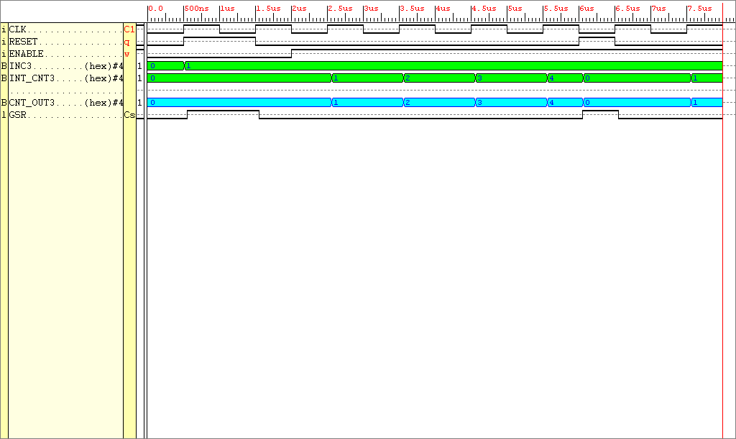
Figure34: Simulation results gathered from the implemented entity Counter

Notice the output of the counter is four bits wide, this may need to be changed after initial testing, maximum count available with this counter is 15. Knowing the entity performed true to it’s design it was then placed and routed using the Xilinx Foundation Software. This allowed further analysis such as FPGA routing constraints, and physical size determination. The Counter entity required 4 complex logic blocks. There is one more item required by the DSP, and that is the seven segment display decoding entity.
The seven segment encoder is required to fetch and decode the processing count and the value of each element of the 3x3 answer product matrix in turn. To output the matrix answer and the number of processing clock cycles to the seven segment displays would require many outputs. As analysed on page 43, the maximum magnitude an element of the matrix product can be is 27. 27 is a two digit number, 2 seven segment displays would be required to display this number. Hence 18 seven segment displays are required to display the 3x3 matrix product plus 1 or 2 displays for the processing count, maximum total displays required, 20. 20 seven segment displays alone require 280 (20 x 14) inputs. The FPGA has a maximum of 63 outputs available; a compromise must exist between FPGA outputs and number of seven segment displays outputted to. One segment of the matrix product should be outputted at a time. Hence 14 outputs from the FPGA are required in order to generate the matrix product segment , 10 clock cycles and 10 different select input signals would be required to output the full answer. What hasn’t been explained yet is how the seven segment display data will get to it’s correct destination on the seven segment display board, this will be explained later. The behaviour model of Entity Seven_Seg_Enc can be viewed in the appendix of this report.

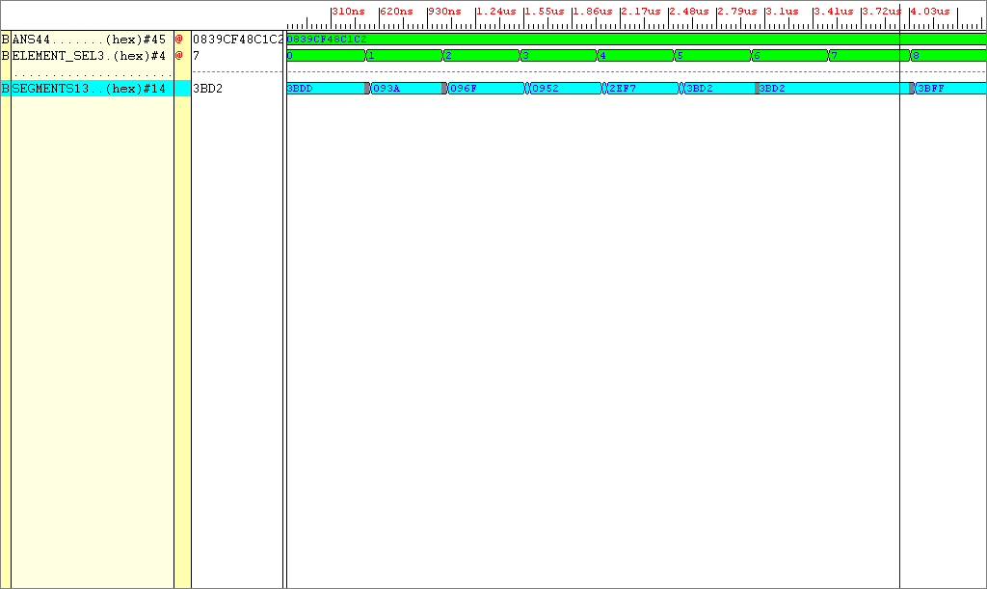
Figure35: Simulation Results from ENTITY Seven_Seg_Enc

The test pattern shown as applied to the input ANS was 8 7 7 7 20 17 16 14 2, each of these digits are five bits wide, each number represents an element of the product matrix (hence the number 2 will be bit extended i.e. padded zeros will be placed in front of it’s binary equivalent).

Decimal test pattern data 8 7 7 7 20 17 16 14 2
Binary (5bit) conversion 01000 00111 00111 00111 10100 10001 10000 01110 00010
Binary (4bit) grouping 0.1000.0011.1001.1100.1111.0100.1000.1100.0001.1100.0010
Hexadecimal conversion 0839CF48C1C2

The test pattern is then converted to hexadecimal equivalent. The result is shown on the simulation input as 0839CF48C1C2. Dependant on the ELEMENT_SEL value (10 selections, 4bit select signal), 1 of the 10 segment values will be outputted in seven segment display encoding. The output in blue refers to the hexadecimal value (a 14bit binary value) required to stimulate two seven segment displays. Knowing the entity performed true to it’s design it was then placed and routed using the Xilinx Foundation Software. This allowed further analysis such as FPGA routing constraints, and physical size determination. The Seven_Seg_Enc entity required 95 complex logic blocks.
The total number of CLB’s required for the DSP in total is

Data_Store : 6 CLB’s
Multiplier : 54 CLB’s
Adder : 54 CLB’s
Answer_Store : 23 CLB’s
Counter : 4 CLB’s
Seven_Seg_En : 95 CLB’s
Total : 237 CLB’s

There are a total of 400 CLB’s available on the XC4010XL PC84 FPGA, which means only 163 CLB’s are available for the finite state machine.
With all the DSP completed, the finite state machine can now be created. Before delving straight into it’s design lets look at a high level view of the whole system thus far. The finite state machine will then be built round these DSP parts.

RESET
CLK
10 7-SEG DISPLAY ENABLING SIGNALS

FSM
MODE
SELECT
SIGNALS

CLK
CNTR_EN SIGNAL
RESET
CLK
SELECTS ONE ELEMENT PRODUCT
14 DATA
SIGNALS
SENT TO TWO
7-SEG DISPLAYS
ANSWER OUTPUT ENABLE
8 INPUTS
External CLK, data and select lines

Data Store

Multipliers

Adders

Counter

Answer Store

Seven Seg Enc
COUNT_OUTPUT

Figure 36: Conceptual view of the 3x3 matrix multiplier system
The FSM controller will be made to operate in 8 different modes, controlled via an 8-bit set of inputs i.e. 4 modes are used for parallel manipulation, the remaining 4 are used for serial operation. But which multiplying operations could this system perform:-

Remember Matrix_A will multiply happily with Matrix_B IF the number of columns in Matrix_A equals the number of rows in Matrix_B.

The following matrix multiplications have been chosen at random from the available matrix multiplications for matrices with dimensions 3x3 and smaller.

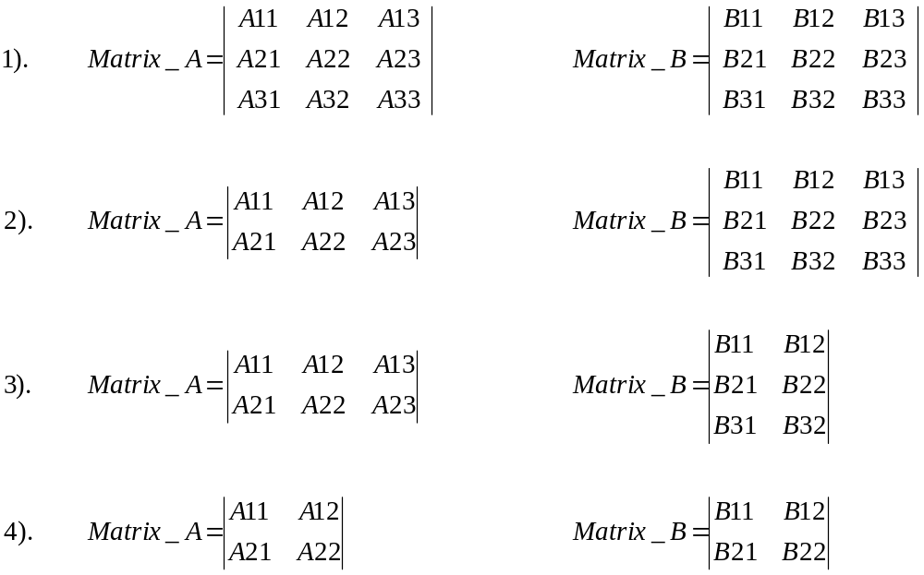

How’s the processing power of the system going to be measured using the serial mode?

An entity is needed in-between entities Data_Store and Multipliers. This entity will select the input data in accordance with the finite state machine mode select signals. Hence when serial mode is selected the data from this entity called “Inter_Store” outputs the element coefficients one at a time, hence in the worst case 18 clock cycles will be required to achieve the answer serially for two 3x3 matrix multiplications.

Instead of having 8 mode select signals input to the Finite State Machine, have 5, Why?

One input selects either the serial or parallel multiplication mode. The other four inputs select what size matrices are to be multiplied.
For the entity Inter_Store to operate require DECIMAL “19” selects. 19 requires five binary digits. Hence this entity requires a CLK, RESET, 36-bit inputs, a 5-bit select and a 36-bit output. Fingers crossed, hope this ENTITY doesn’t take up too much FPGA space.

This is a description of how this ENTITY works, the brains are used in the selection of data. If parallel mode is selected, all data will be outputted from the entity in parallel. If serial mode is selected, then dependant on what mode of matrix operation is selected, data will be outputted from the device in a serial nature. If the matrices in question are of a small size, then less clock cycles are required to pass all of it’s data onto arithmetic logic. The behaviour model of Entity Inter_Store can be viewed in the appendix of this report.
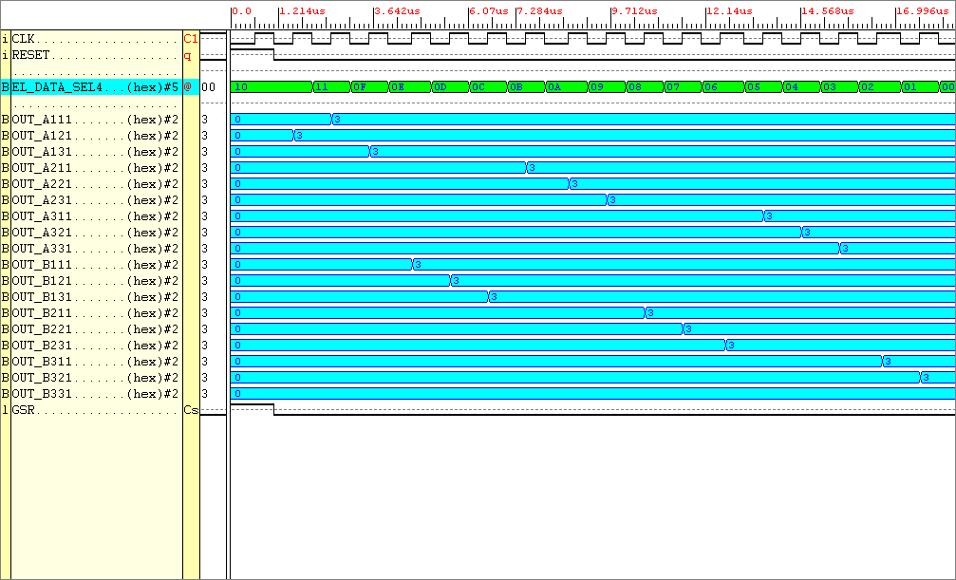
Figure37: Simulation results for the Entity INTER_STORE

Looking at the results above. It can be seen (the input signals are not shown but there are 18 of them) when the data_select signal is in the region 0 to 17 one of the inputs is outputted. When data_select(17) is chosen all the data is outputted in one instance. Knowing the entity performed true to it’s design it was then placed and routed using the Xilinx Foundation Software. This allowed further analysis such as FPGA routing constraints, and physical size determination. The Inter_Store entity required 63 complex logic blocks.
Figure 36 can now be updated to include the this new information derived from further analysis of the DSP components.

10-BIT
7-SEG DISPLAY ENABLING SIGNALS
CNTR_EN SIGNAL (1-bit)
5-BIT MODE
SELECT
SIGNALS
COUNT_OUTPUT

SELECTS ONE ELEMENT PRODUCT (4-bits)
DATA SELECT
RESET
CLK
RESET
ANSWER OUTPUT ENABLE (1-bit)
8 INPUTS
External CLK, data and select lines

FSM

Data Store

Multipliers

Adders

Counter

Answer Store

Seven Seg Enc

Inter
Store
RESET
CLK
RESET

14 DATA
SIGNALS
SENT TO TWO
7-SEG DISPLAYS

CLK
CLK
CNTR_EN SIGNAL

Figure38: Update of the complete system (Red arrows signify, connected outside FPGA).
A test will now be run on the DSP, the matrix data used is shown below
0
1
2
1
3
2
1
3
2
3
2
3
0
2
1
1
3
1

MATRIX_A MATRIX_B

The data needs to be input to the system in 3-bit chunks. Taking Matrix_A data to begin with, writing down each elements data in a row by row basis, followed by Matrix_B data, we have.

10 01 00 11 10 01 01 11 10 11 00 11 10 01 10 01 11 01

Split the data into 3-bit entities we have

3-bit
block Index 11 10 9 8 7 6 5 4 3 2 1 0
Bit steam
100
100
111
001
101
011
110
100
011
110
110
011
Integer Value 4 4 7 1 3 6 6 3 4 6 3 5

The Product Matrix is calculated below:-

(2 x 3) + (1 x 2) + (0 x 1) = 8
(3 x 3) + (2 x 2) + (1 x 1) = 14
(1 x 3) + (3 x 2) + (2 x 1) = 11

(2 x 0) + (1 x 1) + (0 x 3) = 1
(3 x 0) + (2 x 1) + (1 x 3) = 5
(1 x 0) + (3 x 1) + (2 x 3) = 9

(2 x 3) + (1 x 2) + (0 x 1) = 8
(3 x 3) + (2 x 2) + (1 x 1) = 14
(1 x 3) + (3 x 2) + (2 x 1) = 11

The DSP does work correctly. Shown below are the outputs from the system corresponding to element select signal (shown in Figure 38):-

Element Product Select 7seg Data Sig(hex) Number displayed

9 3BFF 8 --ELEMENT 1
8 093A 14 -- ELEMENT 2
7 0912 11 -- ELEMENT 3
6 3B92 1 -- ELEMENT 4
5 3BEB 5 -- ELEMENT 5
4 3BFB 9 -- ELEMENT 6
3 3BFF 8 -- ELEMENT 7
2 093A 14 -- ELEMENT 8
1 0912 11 -- ELEMENT 9
0 3BDB 3 -- COUNTER ELEMENT

To view the tests performed on the full range of matrices please refer to the appendices.

The Finite State Machine

In order to signify to the finite state machine “data has now been loaded into the data store entity now act upon it,” there must be a signal between these two entities in order to communicate this information. A one_bit output from the ENTITY Data_Store to the FSM will be used, that flags “ready to start computing,” this signal will be called Start_Com. This will now need to be implemented by the Data_Store Entity, DSP Entity, and used as an input to the matrix state machine.

The MATRIX MODE INPUT (5-bits) tells the system how to handle the incoming element data, there are 4 modes available.
- IF two 3x3 matrices are being multiplied together then the matrix mode MUST be set to BIN 11000, HEX 18 (FULL PARALLEL MULTIPLICATION) OR BIN 01000, HEX 08 (FULL SERIAL MULTIPLICATION), the most significant bit stipulates the mode of operation either parallel ‘1’ OR serial ‘0’.
- IF a 2x3 matrix is being multiplied by a 3x3 then the matrix mode MUST be set to BIN 10100, HEX 14 (FULL PARALLEL MULTIPLICATION) OR BIN 01000, HEX 04 (FULL SERIAL MULTIPLICATION), the most significant bit stipulates the mode of operation either parallel ‘1’ OR serial ‘0’.
- IF a 2x2 matrix is being multiplied by a 2x2 then the matrix mode MUST be set to BIN 10001, HEX 11 (FULL PARALLEL MULTIPLICATION) OR BIN 01001, HEX 01 (FULL SERIAL MULTIPLICATION), the most significant bit stipulates the mode of operation either parallel ‘1’ OR serial ‘0’.

